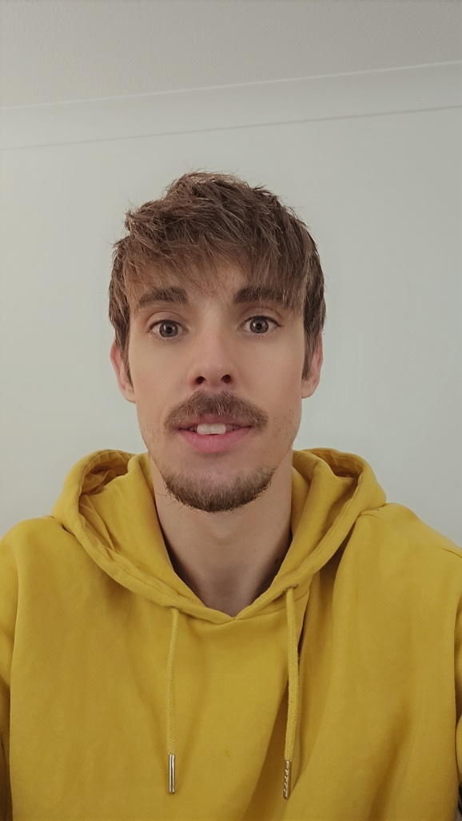
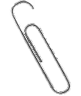
Personality
I give off “Dad energy” dad jokes, dad dancing, I can be strict in certain circumstances but there is a real risk of temptation if puppies are in question. Or maybe a llama if we have room for it.
I have ADHD and feel that is every apparent when meeting me. If you flirt with me, you will have to make it very obvious as I will not realise. This has happened on at least 5 occasions that I have been made aware of.
Ryan Stephenson

Basics
DOB: Feb 1994
Height:,179cm 5'10
Sexuality- Demisexual however has only been attracted to cis women so I think that makes me “Semi Demi”.
Monogamous
Living in Beverley, UK
I can Drive, and have a yellow campervan called Vera.
Drinks socially but not often, I can’t smoke or be around smoke, okay with edibles but don’t actively purchase them.
Job: Housing influence officer
Education: 2 years at university had to drop out due to health issues
Kink friendly to a degree.
I have cystic fibrosis duh.
I like going to the gym, movie and Tv nights, going out into nature. Reading, crafts, trying new things. Being happy with my inner child, I’m more than happy to build a fort in the house to cuddle and watch a movie with hot chocolate and pizza. I do like to cook but I can fall out of love with food after long periods of increased calorie intake.
I have set myself goals for this year and often do. My therapist said I’m extremely gaol driven even if my goal is to relax to avoid making myself unwell.
More woke, liberal, an ally of LGBTQIA+ community, pro-choice.
Values
- Emotional maturity
- Support each other with life goals. We won’t always be aiming for the same things but if can help you with yours and you can help me with mine. We can still share the victories.
- Fighting for relationships
- Supporter of people so I will like other women’s (and men’s) Instagram post within reason. Not insta models posting “seductive pics” but if someone I follow posts an image to support body positivity, then I will like it. But I do try to display that it is just for support. I find some people feel I can be flirty, but I try to establish that I am not doing it deliberately and I am happy to change any behaviour should it make you/women/people uncomfortable.
- I am possibly open to kids but not 100% due to life expectancies.
- I would like regular dates regardless of stage of relationship (like dating after marriage, making time for each other)
- Relationships aren’t always going to be 50/50 but should always aim to equal 100. If it is one sided for long a long period it is important to communicate why that is.
- I want to marry someone I could call my best friend.
- I like to keep little things from the relationship and will keep things from past relationships. Not due to unrequited feelings but because those memories are special to me.
- I believe in never stop dating your partner. In life we change it is natural and a positive thing. So, I feel you should always seek to learn who this new version of them is and fall for them all over again. Unless your goals are vastly different then it is kinder to let them go and love each other while not in a relationship.
- I’m very family orientated. Should things develop my family WILL want to meet you at a family gathering. It can be daunting but I should be more scared than you.
Life goals
I’m very goal oriented and not having a goal to strive for does affect me mentally. However, due to this constant need I have very realistic/ short term goals usually in the process but I do have few larger goals broken down into smaller steps.
- Travel at least one weekend a month in Vera my campervan. Hopefully with nova my dog once she’s trained and used to it.
- I want to explore my interests like watch making etc.
- I’d like to be more financially secure. Basically, have savings to fall back on just in case.
- A big goal of mine is to drive to lake Garda and explore Europe on a road trip. I will need a DJ.
- I’m open to children depending on time.
- I want to be happy with the body I have. I have a few “good angles” but I dislike my body currently.
- Hopefully married by 35
This list will constantly be growing and changing so should be meet we can talk about these together and talk about your goals too.
Downsides to dating me
- I WILL eat your snacks...but I’m also willing to buy replacements haha.
- I can get unwell easily and can require to eat a lot.
- I work a 9-5 and have to fit in gym and medication so I may not have as much time as I like to date.
- I am recently recovering from financial issues but can get by easily now.
- I don’t do breakups the best unless its communication is done well. The two times I have acted poorly was when I had been lied to and left with unanswered questions.
- I’m a people pleaser.
- I still say “that’s what she said” in 2024 and sometimes at inappropriate times.
- My social battery can die quickly.
- I’m trying to focus on my self-image and I feel that may lead to appearing vain.
- My spelling and grammar can be poor unless I check it.
- I struggle with tone/nuances in text so I use emoji a lot but don’t quite understand the new idea some can be seen as passive aggressive.

Love languages!
Not only that I feel that we all change over time, and these may score differently for each relationship. Here are my scores as of 2024.

While I like these and feel they can give a couple a good indication of where their partner stands. I found in my most recent relationship sometimes they’re preferred method isn’t always possible, I had started a new job so quality time had taken a huge decline from what we first had. So, I would buy her flowers regularly for no reason just to remind her I still cared, when money became an issue that would upset me because I felt I couldn’t provide. However, I would always call her beautiful, comment on her social media and post her on my socials. I feel its still important to still try to show love and affection in some way.
Where I am now
I am currently working on myself to develop my self-esteem and overall physical health. I want to travel regularly in my campervan hopefully at least one weekend a month. I am just recovering from a really unfortunate financial situation so this next year or so (max) I will have limited funds for larger dates/expenses. I am good with my money however and can make exemptions providing enough notification and planning/budgeting.
I feel like I am happy being single and have done for most my life. I do have anxiety about a potentially short life expectancy, but I’ve always wanted someone to share my life with on a deeper level than my amazing friends and family. If I see that in my future I would like that life to start as soon as possible, with the right person. I don’t agree with wasting our time if one of us doesn’t see it working out.
Deal breakers!
- Cheating
- Being rude to staff
- Not allowing contact with female friends
- Poor communication skills and low emotional maturity
- Projecting insecurities
- Over drinking on regular occasions
- Sleeping with socks on.... just kidding but gross. haha
- Must like dogs.
- Not getting on with my family and friends
- Has or is constantly around and involved in drama.

References
You can speak to any of my friends on request.

Quotes
“You’re the perfect guy, not for me, but for tee.” A close friend
“You have a nice dick. It’s a nice size” naked attraction and drunken friends.
“you’re pretty weird aren’t you Ryan?” too many people.
“You look like the rat from flushed away....in a good way” random drunk lady.
“Nation’s sweetheart” Hull daily mail. Not joking unfortunately
“Ryan has the biggest heart with the best sense of humour, you can always rely on him” An amazing former work friend.

Well that’s me. If you think we’ll be a good match, let me know. I look forward to getting to know you.

Experience
• Relationship: August 2021- March 2024 (long term, living together, shared pets and matching tattoos and plans to marry)
Nearly 3-year relationship, reason for termination- My side, money issues caused by horrendous landlord caused me unbelievable stress and it affected both my mental and physical health. My now ex-partner also had mental health issues that caused her to drink a lot, have insecurity issues and had sensory issues that would also add on to my physical and mental decline, that would also affect her mental health and became a vicious cycle. When struggling we would never deliberately hurt each other and in the time we have together we never would insult or attack each other physically or verbally. We just lost any passion or drive to continue the relationship and she chose to end it for both of us to work on our health while being apart. Until recently there was no bad blood, but I don’t believe we will be close or friends again in the future. We do technically share a dog that is living with me but I’m not sure on her commitment to keeping Nova in her life at this stage.
- Lockdown romance: Early lockdown- November 2020 (Short term with possibility to progress after lockdown, monthly written letters, matching bracelets, deep conversations and understanding of medical history, plans to travel)
While this was a short-term relationship that would fit between the talking and dating stages as we could only date on facetime. She was my first love, and it was confusing feeling that way about someone I was yet to meet in person. She had messaged me after seeing me on naked attraction and wanted to see if I was doing ok during lockdown. She made my lockdown a happy time in my life (aside the tragic events unfolding in the world and loved ones being lost) The relationship ended as her life became difficult and was progressing in a relationship with another man. We cut all contact after, but I would write some posts on my blog like I was writing my letters to her. Purely because of her understanding of me and my condition. In recent months we follow each other on TikTok but no communication is taking place.
My experience is limited but I wish both the best in their future endeavours.
I have had a few physical relations with women in the past with my “body count” being 6 (as of April 2024) but these situations turned completed and bitter. I had a poor attitude on dating due to my health and established it would be purely physical, but some had caught feelings and I had to remind them it was not something I wished to pursue. This was taken personally, and I have been referred to as toxic by some. I struggle with this as I was very firm on my boundaries. I no longer want to pursue purely physical relationships in the future to avoid those situations again.

Looking for
- Ages range 26-32 with a year or two exceptions if there is a strong connection but it will be a big if
- Not usually go on looks but I’m a sucker for a nice smile, dimples, and more importantly kind eyes.
- Someone with no mental health issues or is in therapy. Absolutely no judgement, it is purely from past experiences supporting other I find I put my own needs to the side and can affect my physical health. It’s not nice for either one of us but I’m working on it. I too am getting therapy or have access to a therapist.
- I’m not picky on size, however, in the past “bigger women” feel uncomfortable dating a very skinny guy and may affect their mental health. So, I tend to be drawn towards slimmer to curvy women or women confident in themselves. Again, I can’t judge. Body image in regard to self-esteem is something I also need help with and will be working on.
- Not a huge fan of things like lip fillers and a lot of body hair however, I feel it is just a preference and am willing to make acceptations on personality and connection. Your body your choice. Partners can have preferences but I feel it’s wrong to totally judge someone on appearance alone.
- Outgoing and adventurous.
- Loved film and TV.
- OK with listening to music around the house.
- Happy giving personal space.
- Singing in the car and dancing in the kitchen
- Not afraid to be silly/ goofy.
- Sexually confident. Consent is very important to me and I struggle with knowing if you are happy with the situation etc. I don’t pick up hints easily So typically I will attempt to be mentally stimulating. I don’t have to ask if you are open to sexual contact if you’re the one pulling my clothes off haha.
- Open to Dark humour
- I will get sick from time to time but I don’t need someone to mommy me. I’m very independent but if I can get minimal support that would be very helpful. Also, you will need to be understanding that I will be in hospital from time to time. Things may get serious but I’d like you to trust me not to worry...unless I am worried.
- I am looking to potentially marry (while having a healthy understanding the natural stages of a relationship and accepting people change and may not wish to continue with the relationship along the journey)
- If you fit the bill I am still pursing my goals and changes I would like to make to grow as a person before committing to another person in the long term. So, the next stage would be friendship/ talking stage for the foreseeable future.

